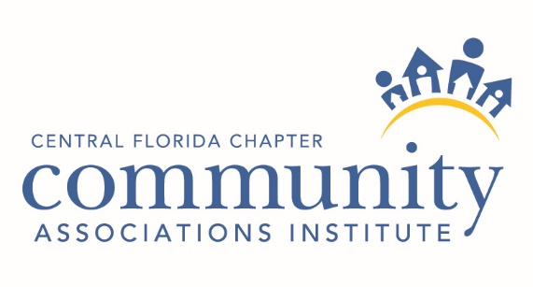

PMDP Education Courses

Central Florida Chapter Reimbursement Form
Name: _____________________________________________________________
Address: ___________________________________________________________
City: __________________________ State & Zip Code: _____________________
Phone: ________________________ Email: ______________________________
CAI #: _________________________ Date of Course: _______________________
Course Name: _______________________________________________________
Instructor: __________________________________________________________
Passing Score: _______________________________________________________

The Chapter policy is to reimburse for half the cost of the course. In order for the Chapter to reimburse individuals for course completion, the individual must request the reimbursement, provide proof of passing the course, send payment receipt and complete this form. Please attach correspondence from National CAI with proof of passing score and they payment receipt for the class.
Reimbursement must be requested with in 90 days of receiving your passing score.

